Afr-Egy- Isis and Nefertari

*from a large estate sale of a late, affluent, world traveler from a historic section of West Hartford CT. Many of the antiques, oddities, and collectibles were acquired during a lifetime of global travel and collecting. Items will be described to the best of our ability. For more treasures from this collection please* [*click here*](http://search.ebay.com/?sass=phins_81&ht=-1)*!*   
  
You are bidding on a beautiful vintage replica of an ancient Egyptian hieroglyphic relief. The material is Plaster of Paris formed on a wooden back frame. Dimensions are 11 9/16"W x 25 1/4"H Thickness is 3/4" (1 1/4" with wood frame)  
These items came from Cairo in the 70's.  
  
Art depicts Isis and Nefertari. An excerpt from (http://www.swarthmore.edu/Humanities/pschmid1/essays/Nefertari/third.chamber.html) best describes this circumstance from Nefertari's last tomb chamber:  
*As Nefertari is about to step across into the world of the dead, she and Isis hold hands, intertwining thumbs. At Nefertari's mouth and nostrils Isis places an ankh, the hieroglyph of breath, life, spirit. It does not seem to mark the last breath leaving the body when a person dies. Rather, it marks the gift of immortality. Nefertari does not expire or exhale, but inhales.*  
  
Item is in great condition and is ready for mounting. There is only one spot with chipping on the face. It is seen in picture #7 and doesn't take away from the art or hieroglyphs. Item is sold as-is.

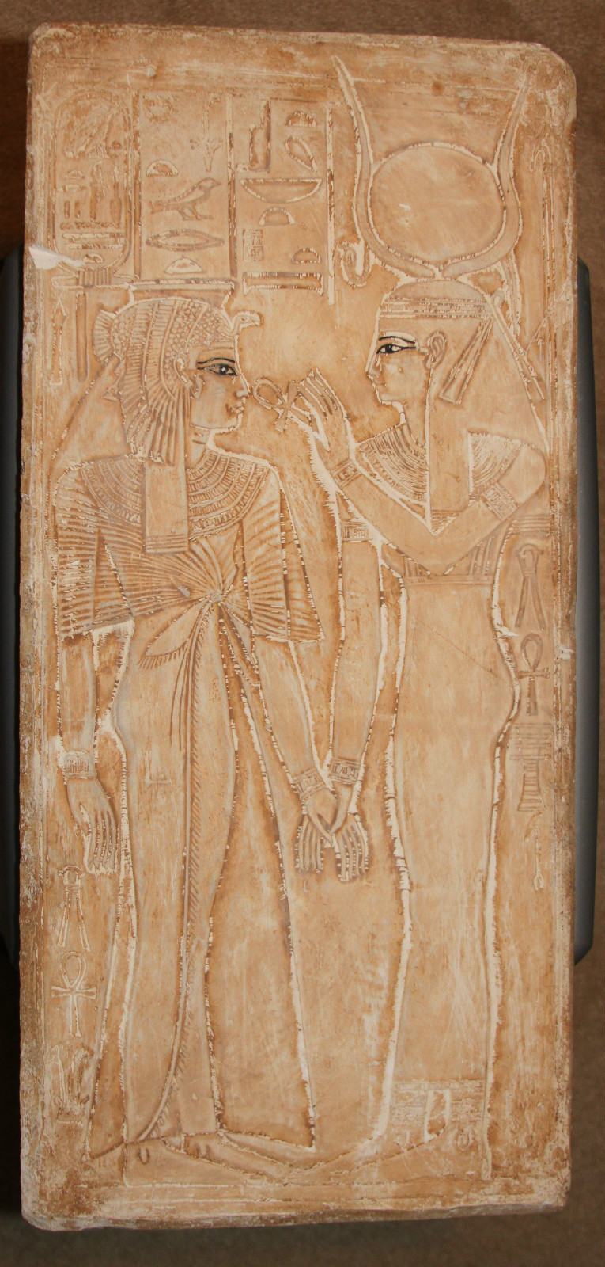

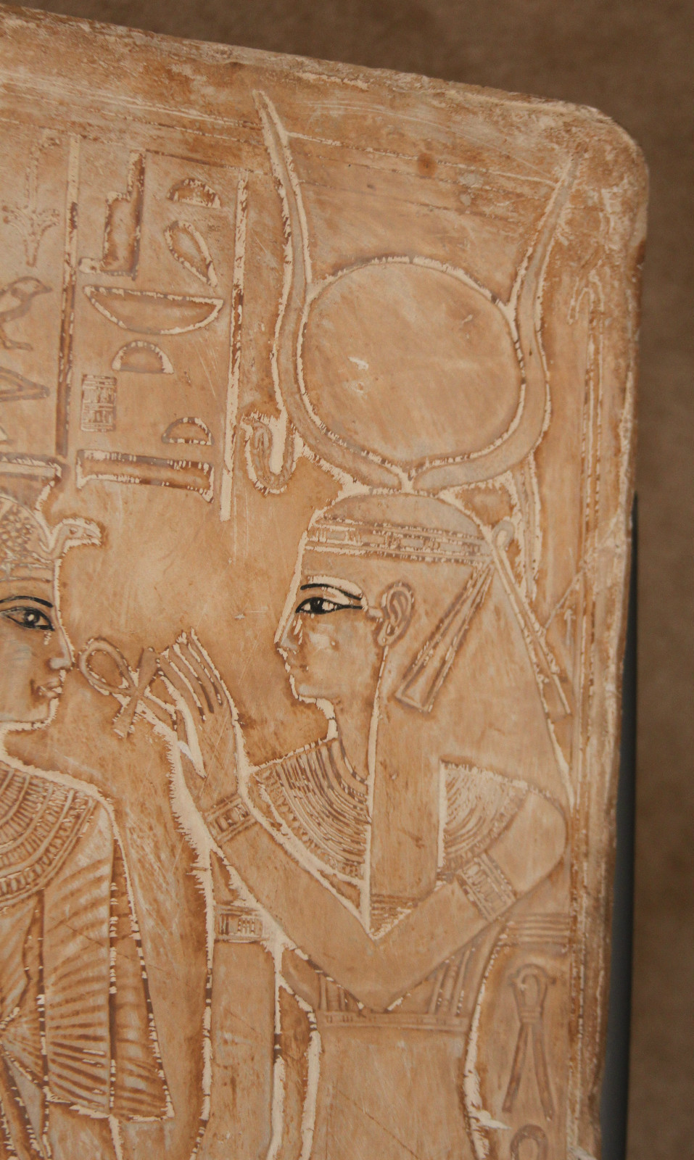 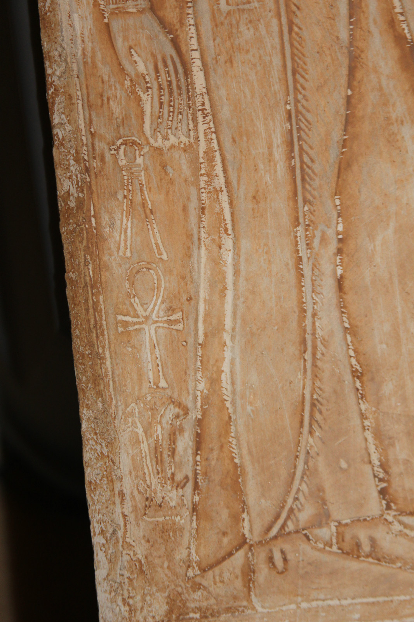 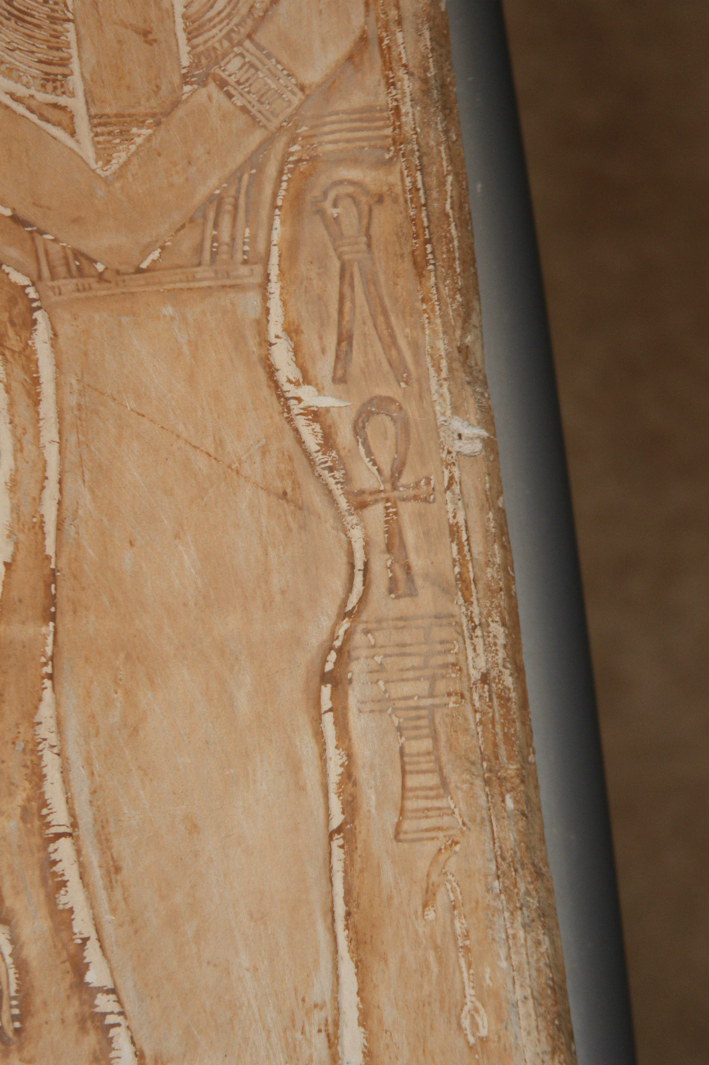 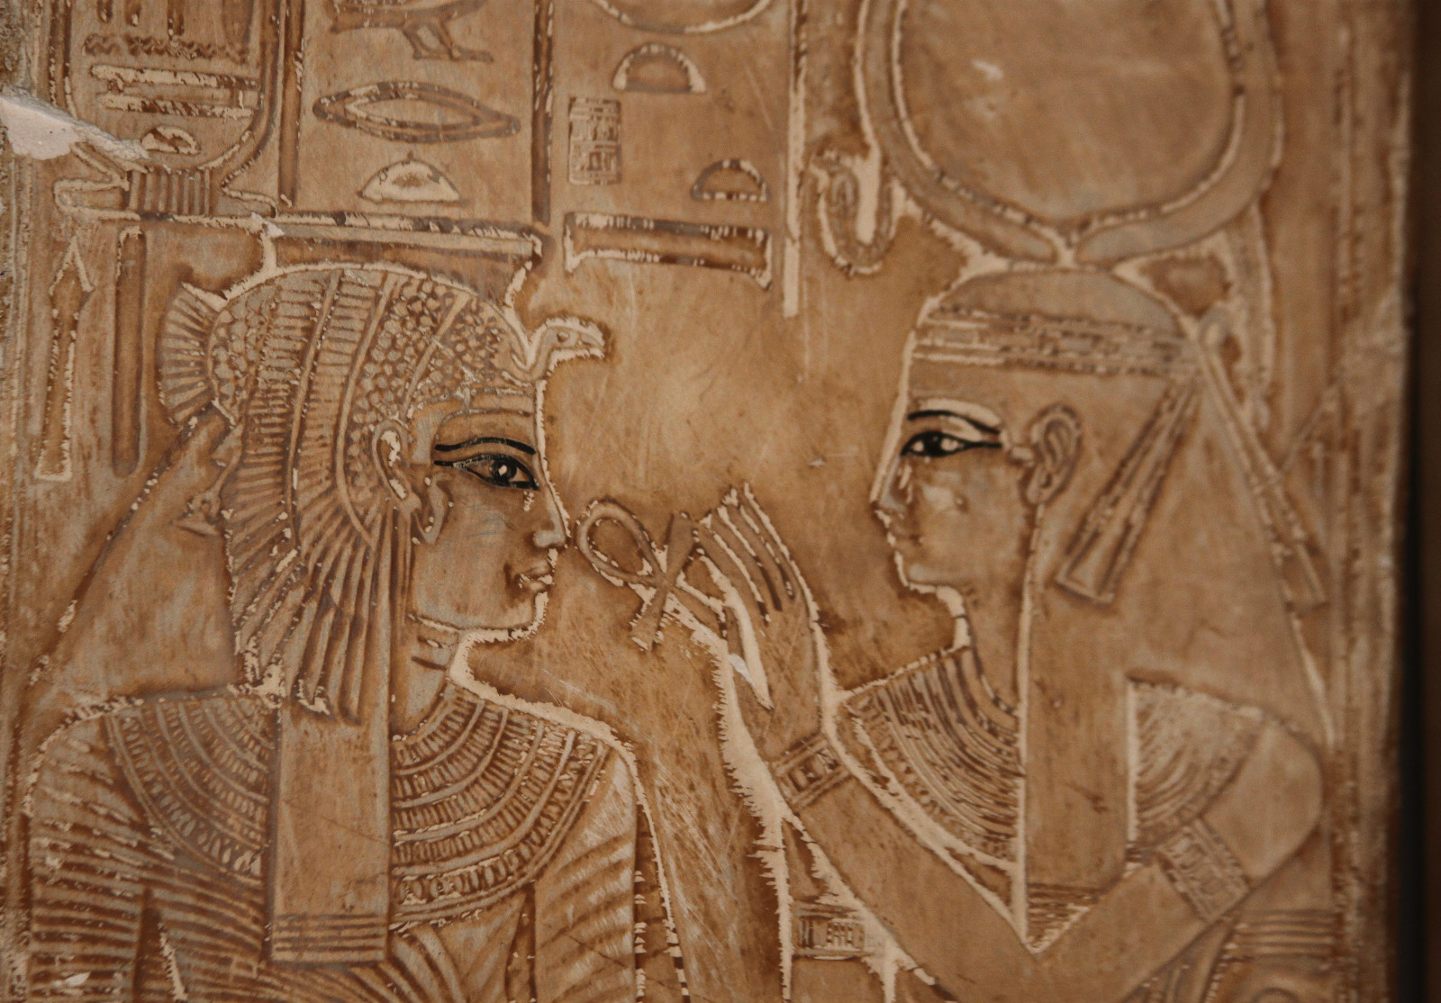 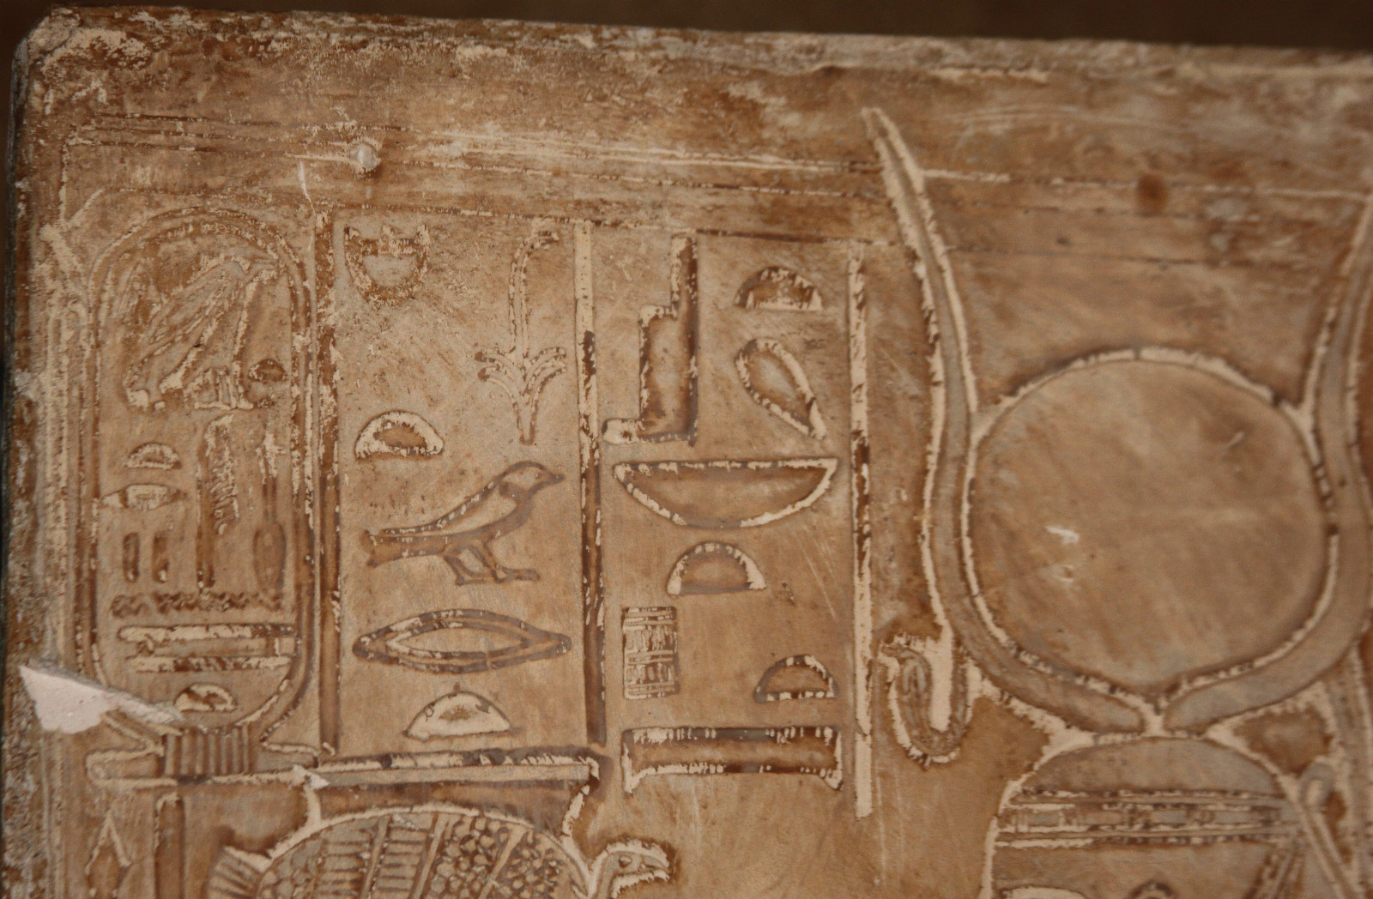

|  |
| --- |
| Shipping details |
| **Ralph J Coffman Jr**  149 Atlantic Ave  Swampscott MA 01907-2427  United States |

## Order details

|  |  |  |  |
| --- | --- | --- | --- |
| **Item title** | **Available actions** | **Shipping & handling (estimated delivery*)** | **Price** |

[Printer version](http://payments.ebay.com/ws/eBayISAPI.dll?ViewPaymentStatus&transid=0&userloginid=802-867&orderid=125015167016&printerversion=true&itemid=230898290908)

|  |  |  |
| --- | --- | --- |
| Seller: | [**Member id** phins_81](http://myworld.ebay.com/phins_81) ( [**Feedback Score Of** 520](http://feedback.ebay.com/ws/eBayISAPI.dll?ViewFeedback&userid=phins_81)) | [Contact seller](http://contact.ebay.com/ws/eBayISAPI.dll?ShowCoreAskSellerQuestion&frm=3998&iid=0&redirect=0&requested=phins_81) |

|  |  |  |  |  |
| --- | --- | --- | --- | --- |
| **Order # 125015167016**  Paid on Dec-23-12 via PayPal | | | | |
|  |  | |  | | --- | |  | | |  |  | | --- | --- | | [Contact seller](http://contact.ebay.com/ws/eBayISAPI.dll?ShowCoreAskSellerQuestion&frm=3998&iid=230898290908&redirect=0&requested=phins_81) |  | | |  |  |

|  |  |  |  |  |  |  |  |
| --- | --- | --- | --- | --- | --- | --- | --- |
| [**Item Title:**Ancient Egyptian ISIS & NEFERTARI Hieroglyphic Plaster Relief Slab Cairo 12x25 **- opens in a new window or tab**](http://cgi.ebay.com/ws/eBayISAPI.dll?ViewItem&item=230898290908)  **Item Id:**230898290908 - Price: US $69.95  Quantity:1  **eBay note:**  Having a problem with this purchase? [We can help](javascript:;) | |  | | --- | |  | | |  |  | | --- | --- | | [Leave feedback](http://feedback.ebay.com/ws/eBayISAPI.dll?LeaveFeedbackShow&useridfrom=802-867&useridto=phins_81&item=230898290908&transactid=0) |  | | | Standard Shipping: **US $28.68**  Estimated delivery: December 28 - January 4 | US $69.95 |
| [**Item Title:**Ancient Egyptian Goddess HATHOR Hieroglyphic Plaster Relief Slab Cairo 9x20 **- opens in a new window or tab**](http://cgi.ebay.com/ws/eBayISAPI.dll?ViewItem&item=230898290909)  **Item Id:**230898290909 - Price: US $49.95  Quantity:1  **eBay note:**  Having a problem with this purchase? [We can help](javascript:;) | |  | | --- | |  | | |  |  | | --- | --- | | [Leave feedback](http://feedback.ebay.com/ws/eBayISAPI.dll?LeaveFeedbackShow&useridfrom=802-867&useridto=phins_81&item=230898290909&transactid=0) |  | | | Shipped with item above | US $49.95 |

|  |  |  |  |  |  |  |  |
| --- | --- | --- | --- | --- | --- | --- | --- |
| [**Item Title:**ANTIQUE SOLID BRONZE Deer Ungulate Animal Hand Carved Sculpture - Patina**- opens in a new window or tab**](http://cgi.ebay.com/ws/eBayISAPI.dll?ViewItem&item=230898300819)  **Item Id:**230898300819 - Price: US $4.95  Quantity:1  **eBay note:**  Having a problem with this purchase? [We can help](javascript:;) | |  | | --- | |  | | |  |  | | --- | --- | | [Leave feedback](http://feedback.ebay.com/ws/eBayISAPI.dll?LeaveFeedbackShow&useridfrom=802-867&useridto=phins_81&item=230898300819&transactid=0) |  | | | Shipped with item above | US $4.95 |



**Payment Instructions:**

I took $4+ off the Hathor s/h and 100% off deer sculpture s/h for you.

Thank you

|  |  |  |  |  |
| --- | --- | --- | --- | --- |
|  | | |  | |
|  |  | |  |  |  |  |  |  |  |  |  |  |  |  |  |  |  |  |  |  | | --- | --- | --- | --- | --- | --- | --- | --- | --- | --- | --- | --- | --- | --- | --- | --- | --- | --- | | |  | | --- | | |  |  |  |  |  |  |  |  |  |  |  |  |  |  |  | | --- | --- | --- | --- | --- | --- | --- | --- | --- | --- | --- | --- | --- | --- | --- | | |  |  | | --- | --- | | Subtotal: | US $124.85 | |  | | | Shipping & handling: | US $28.68 | |  | | |  | | |  | | | Total: | US $153.53 | | | | | |  |